The Challenge
Taking sex into account can advance basic knowledge regarding stem cells—demonstrating potential sex differences in therapeutic capacity as well as sex differences in receptor-mediated pathways. Basic knowledge of stem cell biology is important to one of the most active areas of stem cell research: inducing pluripotency in cells derived from adult patients and utilizing these cells to repair or reconstruct organs.

Gendered Innovation 1: Identifying Sex Differences in Stem Cell Characteristics
Research using sex as a variable has revealed sex differences in the properties of some adult stem cells. Findings include:
- 1. Differences in Mesenchymal Stem Cell (MSC) Activation
Mesenchymal stem cells, which can be derived from bone marrow and other tissues, can differentiate into bone, fat, muscle, connective tissue, and cartilage (Oreffo et al., 2005). Crisostomo and colleagues demonstrated that sex differences exist in the activation of mesenchymal stem cells (MSC). Researchers stressed murine MSCs in vitro with hypoxia, lipopolysaccharide (LPS), and hydrogen peroxide: they demonstrated that “activation” differed by cell sex: XX cells produced more vascular endothelial growth factor (VEGF, which promotes cell proliferation) and less tumor necrosis factor alpha (TNF-α, which promotes inflammation and apoptosis) than XY cells (Crisostomo et al., 2007).
- 2. Differences in Muscle-Derived Stem Cell (MDSC) Regenerative Capacity
MDSCs have the capacity for myocardial repair as well as skeletal muscle repair. They may also be useful for treating muscular dystrophy, for which existing treatments have limited effect (Jankowski et al., 2002).
- MDSC cell lines display variability in regenerative ability. Using mdx mice, which spontaneously develop muscular dystrophy, Deasy et al. demonstrated that cell sex, independent of other variables such as immune response and exogenous estrogenic effects, exerts a strong effect on regenerative capacity. The mechanism behind these differences is an active area of research.
- Deasy et al. found significant sex differences in regeneration capacity in vivo, with XX cells yielding a higher regeneration index (RI) than XY cells. In vivo studies took advantage of the fact that mdx mouse muscle fibers lack the protein dystrophin; researchers determined RI by quantifying muscle fibers generated from stem cells (i.e., those with dystrophin). Even though all MDSCs could differentiate into dystrophin-expressing fibers in vitro, only XX MDSCs could regenerate robustly in vivo (Deasy et al., 2007).
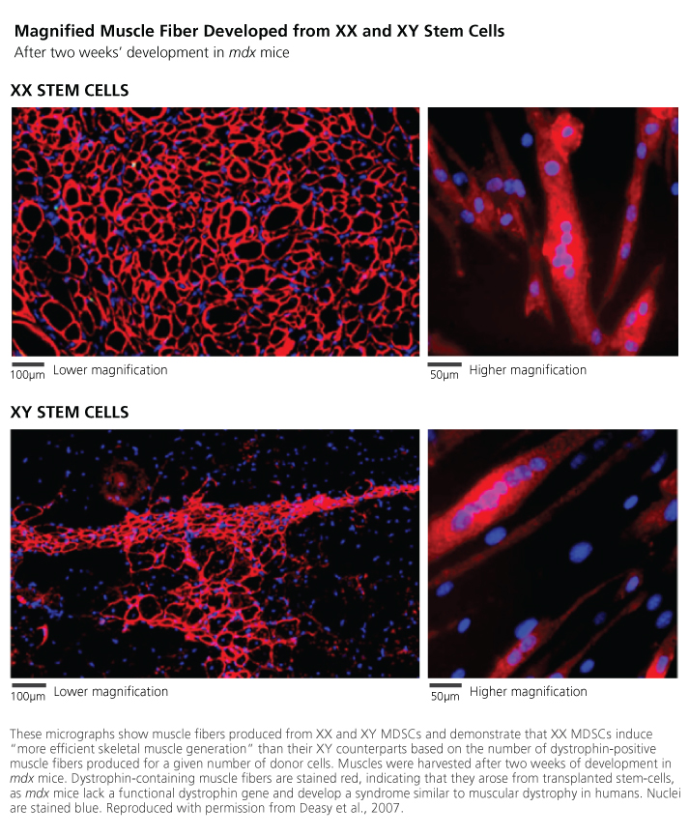
These sex differences may be therapeutically relevant—but because many variables besides sex influence cell behavior, and because the traits of an “ideal” cell type differ depending on the therapy in question, such differences do not indicate that cells of a given sex are broadly therapeutically superior to cells of the other sex. In clinical research using stem cells, there is a “lack [of] direct comparisons of different cell types in clearly defined, clinically relevant models of disease” (Zenovich et al., 2007).

Gendered Innovation 2: Understanding Differences within and between XX and XY Stem Cells
Knowing that sex differences exist in stem cells, researchers sought to elucidate the causes of these differences—work that required analysis of additional factors (see Method).

Method: Analyzing Factors Intersecting with Sex and Gender
Researchers who analyzed sex have observed differences between XX and XY stem cells, but a deeper understanding of stem cell biology requires examination of covariates. Observed sex differences can arise in several ways:
1. Genetics: Female and male stem cells differ in karyotype and therefore differ genetically, but genetic variations also exist between cells of the same sex—not all XX cells or XY cells are alike. Studying the covariates of genotype and investigating both between-sex and within-sex differences is important in stem cell research.
2. Hormonal Environment: Stem cells are sensitive to hormonal environment—often including, but not limited to, the presence of sex hormones. Hormones can have both transient and permanent effects on stem cells, making hormonal environment a necessary covariate to sex (Asselin-Labat et al., 2010).
3. Epigenetics: The DNA sequence of a stem cell is unchanged throughout the cell’s life and is rarely altered by environment. Gene expression, however, can change frequently and dramatically; indeed, such changes account for the ability of genetically identical stem cells to differentiate into functionally distinct somatic cells. These changes are heritable, and so even if cells are cultured in vitro in identical hormonal environments, observed differences cannot be assumed to stem from genetic sequence alone. The environments in which these cells’ ancestors developed may have created epigenetic differences, and they are important covariates (Ohm et al., 2009).
View General Method
Multivariate studies include sex as one variable among many. It is important to test for interactions between sex and other predictors of the outcome under study. Without such testing, one might attribute variability to sex when that difference is actually dependent on another factor. This misattribution can lead to overemphasis of sex differences. Covariate analysis has shown the following:

- 1. Species influences stem cell behavior, and findings in animal models are not necessarily applicable to humans.For example, when pluripotency is induced in murine XX fibroblasts, the resultant induced pluripotent stem cells (iPSCs) show a reversal of X inactivation, with two active X chromosomes. When human XX fibroblasts are treated to induce pluripotency, however, the resultant human iPSCs display one active and one inactive X chromosome (Tchieu et al., 2010).
- 2. In mouse models of muscular dystrophy, both the sex of the donor cell and the sex of the recipient animal matter.Multivariate analysis shows that XX MDSCs promote regeneration more than XY MDSCs (regardless of recipient sex) and that female recipient animals undergo more regeneration than male recipient animals (regardless of donor cell sex). In the mdx model of muscular dystrophy, matching donor sex to recipient sex would not be an optimal strategy for promoting muscular regeneration: XX stem cells are a better treatment option for both females and males (Deasy et al., 2007).
- Further experiments using immune deficient mice suggest that the effect of host sex (but not the effect of cell sex) is immunologically modulated: Researchers “observed no significant difference as a result of host sex” in immune deficient animals, “yet the significant difference as a result of cell sex remained” (Deasy et al., 2007).
- 3. Even when sex is a statistically significant predictor of stem cell behavior, not all cell lines are alike within a sex.Mouse MDSCs show significant variation in regeneration potential within a single sex (Deasy et al., 2007).
- Studies of the 17 human embryonic stem cell lines commonly used in research (9 of which are 46,XX and 8 of which are 46,XY) have shown that different lines have different tendencies to develop into particular types (Osafune et al., 2008). These characteristics could not be predicted on the basis of karyotypic sex alone (Cowan et al., 2004).
- 4. Hormonal Environment Interacts with Stem Cell Sex. The relationships between stem cells and hormones are complex—requiring consideration of the hormonal environment within which a cell or its ancestors developed as well as its current environment, whether in vitro or in vivo. A review by Ray et al. (2008) demonstrates that sex hormones influence the characteristics of many types of stem cells, with effects that vary according to cell 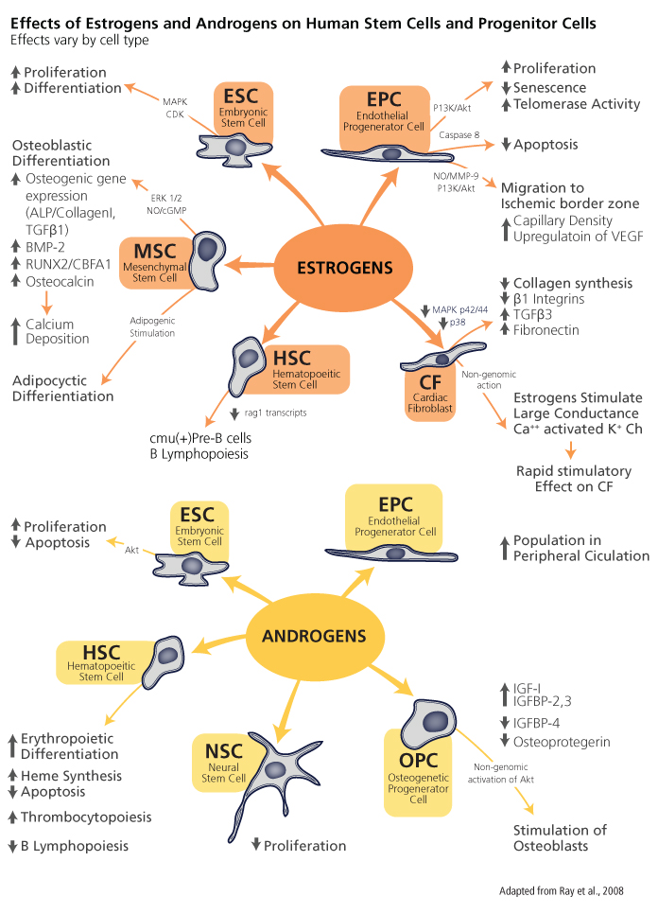

Gendered Innovation 3: Improving Clinical Guidelines for Stem Cell Therapies
When a patient’s own stem cells cannot be used therapeutically, success in stem cell transplantation depends on analyzing the interactions between: 1) the sex of donor cells used; 2) the sex of the host; 3) the type of stem cells transplanted; and 4) the illness being treated (see Method).

Method: Formulating Research Questions
Discoveries about the interactions between species, stem cell sex, recipient sex, and hormonal and immunological variables in animal and in vitro research have prompted researchers to formulate questions relating to stem cell therapies for human patients. Currently, the only stem cell therapy in standard medical practice is hematopoietic stem cell (HSC) transplantation, used primarily to treat malignant disorders but also used in patients with immune deficiency or aplastic anemia (Gratwohl et al., 2010).
View General Method
A study of 1,386 patients undergoing allogeneic HSC transplantation at a single medical center (about 75% for leukemias and the remainder for other conditions) showed that sex matching between donors and recipients correlated with better overall survival, although HSCs from male donors were associated with better long-term survival (Pond et al., 2006).
In pediatric leukemia, HSC transplantation from a female donor to a male recipient produces outcomes that are “unfavorable comparing with all other sex combinations” and “dismal in the presence of an MM (Human Leukocyte Antigen Mismatch).” Donor pregnancy was also found to interact with donor sex and recipient sex; when stem cells are derived from pregnant women donors and given to male patients, the risk of graft-versus-host disease increases (Gustaffson et al., 2004).
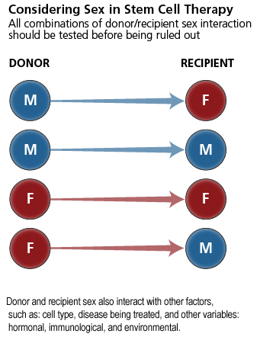

Donor and recipient sex also interact with the covariate of disease type—for example, when HSC transplantation is used to treat multiple myeloma, cells from female donors may produce better outcomes. Women patients who receive female HSCs have lower mortality than women patients treated with male HSCs. For men patients with multiple myeloma, the sex of donor cells did not significantly influence overall mortality, but did influence modes of mortality: Men patients treated with male HSCs were more likely to die from myeloma relapse, whereas men patients treated with female HSCs were more likely to die from non-relapse-related causes, such as graft-versus-host disease (Gahrton et al., 2005).
Systems for matching patients to donors for allogeneic HSC transplants now take donor sex and patient sex into account, along with numerous other variables, in order to optimize outcomes (Lee et al., 2007).

Conclusions
Researchers who reported and analyzed sex at the cellular level have identified sex differences in cell behavior that may be of relevance in developing therapeutics. These findings led researchers to investigate the causes of sex differences and discover both hormonal and genetic factors that govern stem cell behavior. In hematopoietic stem cell transplantation—the only stem cell therapy in widespread clinical use—clinicians have gathered data about interactions between donor sex, recipient sex, and other covariates in order to optimize donor-patient matching for allografts.

Next Steps
In basic research, scientists should be aware of the importance of sex as a variable and, in turn, identify the karyotype of cells used when reporting their research results. Results and null results should be reported (see Analyzing Sex). Reporting cell karyotype is important whether or not sex-based differences exist because this information permits secondary research reviews and meta-analyses. Granting agencies and journal editors can encourage such reporting through grant and publication guidelines.
Send Us Feedback

Works Cited
Asselin-Labat, M., Vaillant, F., Sheridan, J., Pal, B., Simpson, E., Yasuda, H., Smyth, G., Martin, T., Lindeman, G., & Visvader, J. (2010). Control of Mammary Stem Cell Function by Steroid Hormone Signaling. Nature, 465 (7299), 798-802.
Beery, A., & Zucker, I. (2011). Sex Bias in Neuroscience and Biomedical Research. Neuroscience and Biobehavioral Reviews, 35 (3),565-572.
Cowan, C., Klimanskaya, I., McMahon, J., Atienza, J., Witmyer, J., Zucker, J., Wang, S., Morton, C., McMahon, A., Powers, D., & Melton, D. (2004). Derivation of Embryonic Stem-Cell Lines from Human Blastocysts. New England Journal of Medicine, 350 (13),1353-1356.
Crisostomo, P., Markel, T., Wang, M., Lahm, T., Lillemoe, K., & Meldrum, D. (2007). In the Adult Mesenchymal Stem Cell Population, Source Gender Is a Biologically Relevant Aspect of Protective Power. Surgery, 142 (2), 215-221.
Deasy, B., Lu, A., Rubin, R., Huard, J., Tebbets, J., Feduska, J., Schugar, R., Pollett, J., Sun, B., Urish, K., Gharaibeh, B., & Coo, B. (2007). A Role for Cell Sex in Stem Cell-Mediated Skeletal Muscle Regeneration: Female Cells Have Higher Muscle Regeneration Efficiency. The Journal of Cell Biology, 177 (1), 73-86.
Gahrton, G., Iacobelli, S., Apperley, J., Bandini, G., Björkstrand, B., Bladé, J., Boiron, J., Cavo, M., Cornelissen, J., Corradini, P., Kröger, N., Ljungman, P., Michallet, M., Russell, N., Samson, D., Schattenberg, A., Sirohi, B., Verdonck, L., Volin, L., Zander, A., & Niederwieser, D. (2005). The Impact of Donor Gender on Outcome of Allogeneic Hematopoietic Stem Cell Transplantation for Multiple Myeloma: Reduced Relapse Risk in Female to Male Transplants. Bone Marrow Transplantation, 35 (6), 609-617.
Gratwohl, A., Baldomero, H., Aljurm, M., Pasquini, M., Bouzas, L., Yoshimi, A., Szer, J., Lipton, J., Schwendener, A., Gratwohl, M., Frauendorfer, K., Niederwieser, D., Horowitz, M., & Kodera, Y. (2010). Hematopoietic Stem Cell Transplantation: A Global Perspective. Journal of the American Medical Association, 303 (16), 1617-1624.
Gustaffson, Å., Remberger, M., Ringdén, O., & Winiarski, J. (2004). Risk Factors in Pediatric Stem Cell Transplantation for Leukemia. Pediatric Transplantation, 8 (5), 464-474.
Jankowski, R., Deasy, B., & Huard, J. (2002). Muscle-Derived Stem Cells. Gene Therapy, 9 (10), 642-647.
Lee, S., Klein, J., Haagenson, M., Baxter-Lowe, L., Confer, D., Eapen, M., Fernandez-Vina, M., Flomenberg, N., Horowitz, M., Hurley, C., Noreen, H., Oudshoorn, M., Petersdorm, E., Setterholm, M., Spellman, S., Weisdorf, D., Williams, T., & Anasetti, C. (2007). High-Resolution Donor-Recipient HLA (Human Leukocyte Antigen) Matching Contributes to the Success of Unrelated Donor Marrow Transplantation. Blood, 110 (13), 4576-4583.
Ohm, J., & Baylin, S. (2009). Stem Cell Epigenetics. In Rajasekhar, V., & Vemuri, M. (Eds.), Regulatory Networks in Stem Cells, Volume III: Stem Cell Biology and Regenerative Medicine, pp. 235-246. Berlin: Springer Science and Business Media.
Oreffo, R., Cooper, C., Mason, C., & Clements, M. (2005). Mesenchymal Stem Cells: Lineage, Plasticity, and Skeletal Therapeutic Potential. Stem Cell Reviews, 1 (2), 169-178.
Osafune, K., Caron, L., Borowiak, M., Martinez, R., Fitz-Gerals, C., Sato, Y., Cowan, C., Chien, K., & Melton, D. (2008). Marked Differences in Differentiation Propensity among Human Embryonic Stem Cell Lines. Nature Biotechnology, 26 (3), 313-315.
Pond, G., Lipton, J., & Messner, H. (2006). Long-Term Survival after Blood and Marrow Transplantation: Comparison with an Age- and Gender-Matched Normative Population. Biology of Blood and Marrow Transplantation, 12 (4), 422-429.
Ray, R., Novotny, N., Crisostomo, P., Lahm, T., Abaranell, A., & Meldrum, D. (2008). Sex Steroids and Stem Cell Function.Molecular Medicine, 14 (7), 493-501.
Tchieu, J., Kuoy, E., Chin, M., Trinh, H., Patterson, M., Sherman, S., Amiuwu, O., Lindgren, A., Hakimian, S., Zack, J., Clark, A., Pyle, A., Lowry, W., & Plath, K. (2010). Female Human Induced Pluripotent Stem Cells (iPSCs) Retain an Inactive X Chromosome.Cell, 7 (3), 329-342.
Zeller, C., Wang, Y., Markel, T., Weil, B., Abarbanell, A., Herrmann, J., Kelly, M., Coffey, A., & Meldrum, D. (2009). Role of Tumor Necrosis Factor Receptor 1 in Sex Differences of Stem-Cell-Mediated Cardioprotection. Annals of Thoracic Surgery, 87 (3), 812-819.
Zenovich, A., Davis, B., & Taylor, D. (2007). Comparison of Intracardiac Cell Transplantation: Autologous Skeletal Myoblasts versus Bone Marrow Cells. In Kauser, K., & Zeiher, A. (Eds.), Bone Marrow-Derived Progenitors, pp. 117-165. Berlin: Springer Verlag.

